

**كلية العلوم الحاسوبية والمعلوماتية**

Faculty of CSI

**Project Title**

*Students:*

|  |  |
| --- | --- |
| Name of Student 1 | Abdel-Rahman Zahran |
| Name of Student 2 | Ali Choplo |
| Name of Student 3 | Ammar Abuhusain |

*Supervisor:*

Dr. Ahmad Ajarmeh

*Amman - Jordan*

*2024/2025*

**Table of Contents**

1 Introduction ------------------------------------------------------------------page 1

2 Problem Statement and project Scope ------------------------------------page1

2.1. Problem statement ----------------------------------------------------

2.2. Project scope ----------------------------------------------------------

3. Project Plan and Schedule -------------------------------------------------page 2

1. Introduction

Looking at the Internet café’s systems that we saw, we tried to make a new system which the user can easily use it. It has special properties such as: User can log in and register himself, he can extend his booking himself and order what ever he want from his computer.

2. Problem Statement and project Scope

2.1 Problem Statement

Internet cafés require a seamless and efficient management system to provide smooth user experience and ensure customer satisfaction. However, many systems lack an integrated solution that combines user account management, transactions, menu ordering, booking, and feedback collection. This creates issues such as difficulty in managing accounts, inconvenience in ordering and checkout processes, and a lack of customer insights into service improvement.

The system has been facing problems due to its paper-based appointment

system. With the increase in the number of patients visiting, it has

become diﬃcult to manage the appointment system manually. Recording

of appointments and creating registers by pen and paper has become a

2.2 Project Scope

In our **internet café system**, we’d like to have a welcome page that has two choices: either a **Log in** or a **Sign Up** page. Customers can **sign** themself **up** with an E-mail, a new password and credit card information. The **log in** page asks the user to insert an email and a password. If the user has an account and they forgot the password, they can click the **Forgot Password** page to reset the password.

After that, the system takes you to a **Menu** page where it asks the customer what they would like to order from the menu and adds it to the **Checkout** page.

Once the user selects what they want, they click on a button to go to the **Checkout** page. During those hours, the user can extend the booking for as long as needed.

After the user is done, it asks the user to **review the service and program** and to provide feedback on what features would be nice to have or what improvements they would like to see in the internet café. Finally, he can click on the **Log out** buttonwhenever they want.

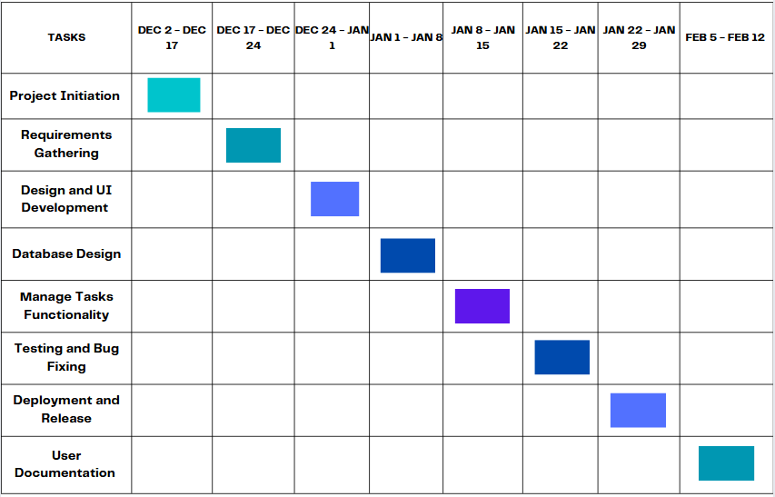3. Project Plan and Schedule